Do you have a relative or close friend who is clearly having significant emotional and/or behavioral problems? Are you struggling to convince the person to get a psychiatric evaluation or treatment? If so, then this book is for you. Click on the link or image below or to see the book on Amazon.com:

You Need Help!: A Step-by-Step Plan to Convince a Loved One to Get Counseling

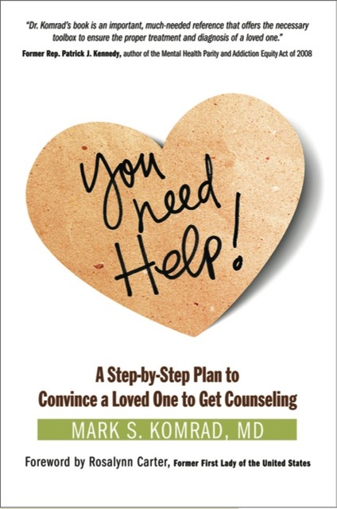

Below is a brief summary of key ideas in this book.

Note: POC “person of concern”—the troubled person you are trying to help.

Step 1: Before you begin

Know the signs that the POC’s problem is serious enough to need professional help.

What makes a problem serious enough to require a professional evaluation?

Figure out why you are getting involved, and why it’s worth it. Look at your motivations and the benefits.

Understand why the POC may have avoided getting professional help so far.

Focus on the goal: getting the POC to have a professional mental health evaluation. That is the sole goal that this book aims for—getting an evaluation.
Step 2: Choose a time and place

Plan in advance on a special time and place to speak, to listen, and to discuss the problem with the POC.

Avoid discussing the problem at defensive times, family gatherings, holidays, special events, in the midst of, or right after an argument.

Approach the POC when everyone is sober.

Speak with the POC face-to-face, not by letter, phone, or email.

Select an emotionally neutral place where the POC doesn’t feel trapped.

Acknowledge up front that the POC might be hurt by this discussion.

Focus on how you feel affected by the POC in your discussion.

Focus on your caring, concern, and love as your point of departure in your approach.

Step 3: The first approach

Let the POC know you are listening, and not just telling him what to do.

Try to make the POC feel that it is safe to talk. There are several ways to do this.

If you feel unsafe, have another person present when you talk with the POC.

Be prepared to tolerate the POC’s anger at your concern, but don’t let that discourage you.

Let the POC have some mixed feelings; he doesn’t have to totally agree at first. This is more of an ongoing process than a one-time effort.

Persist; keep coming back. Don’t give up because you tried discussing getting an evaluation once, and they weren’t interested.

Focus on specific behaviors that you have observed, without using jargon (e.g. “It’s hard on the kids when you wash the dishes for over 2 hours,” rather than, “I’m worried about the OCD-way you wash the dishes.”)

You don’t have to figure out what’s wrong with the POC, just communicate that something is the matter and that a professional can help figure out what, if anything, is the problem.

Acknowledge to the POC that you don’t have the power yourself to completely help him; you need an experienced, trained person to help him too.

Be prepared to ask the POC to get help for YOUR sake, because YOU need more help to support him.

Ask the POC to get an evaluation as a “gift” to you.

If you have benefited from your own treatment, share that with the POC.

Ask the POC to consider a single, one-time visit at this time; just an “evaluation,” not a commitment to “treatment.”

Make the appointment for the POC, or help him to make it, and go along.

Step 4: Gathering your allies

Talk with the POC’s personal physician or other primary care provider about the problem and the need for a psychiatric evaluation. That provider might even be able to provide treatment.

Consider including in your effort a close sibling, dear friend, or clergy with whom the POC has a relationship.

Even before approaching the POC, attend a support group meeting for families and friends, like the National Alliance on Mental Illness (NAMI.org). Hear the experience and advice of others who have done this.

Educate yourself about psychiatric problems by reading through memoirs and movies.

Before approaching the POC, consult with a psychiatrist or other mental health professional yourself about the problem and how to approach the POC.

If you are already getting mental health treatment, let your own treater help you approach the POC.

Step 5: Beyond persuasion to coercion

If a person is rational, persuasion can work, if not, then it may be necessary to engage in “therapeutic coercion”—creating consequences that can result in steering the POC towards getting an evaluation. These techniques are particularly useful in the context of a family, most commonly helpful to parents of an adult child who may be suffering from symptoms of mental illness, but refusing evaluation and treatment.

Accept that logic doesn’t always work.

Understand how friends and family can sometimes have more power than any professional or agency.

Consider that with privileges come responsibilities; in this case, responsibility for the POC to get help for mental health problems.

Use the powers of giving or taking away privileges to influence the POC to get professional help.

Your relationship with the POC is important. In serious situations, be prepared to put the relationship at stake, if necessary.

In rare instances, you may even need to withdraw the privilege of providing a residence for the POC. You’ll need a lot of support and guidance if it comes to that.

Consider using the power of a group, and gather others for an “intervention.”

Be prepared to deal with those who might be “enablers.”

Step 6: “Hardball”: Involuntary evaluation

The book includes a useful “flow chart” for how typical involuntary mental health processes work.

Determine if the POC is dangerous to self or others.

Determine if the danger is imminent.

Know the legal process in your community for involuntary evaluation in the face of immediate dangers.

If mobilizing the legal steps for involuntary evaluation, SHOW UP at each and every step.

When describing the POC’s situation to authorities, share the most serious behaviors you have seen. Don’t hide the worst of it, even if it’s embarrassing.

If the POC is hospitalized, you may have to close your home to his return until he is better.

If the POC is eligible, consider the VA system.

Do not be intimidated by fear of damaging the relationship. Not acting can do more damage than acting to mobilize involuntary evaluation.

If the POC is already in legal trouble, use that as an opportunity to have the court require psychiatric evaluation and treatment as an outpatient.

If the POC is in jail, help to mobilize the psychiatric treatment resources in that facility.

If the POC does not have a legal problem, you may have to initiate one; then ask the court to require evaluation and treatment as a legal consequence.

Understand how the legal system treats mental illness and substance abuse differently.

Protect your own safety and that of children.

Remove firearms if possible and safe.

Step 7: Continuing your support

If you are successful at getting the POC to agree to an evaluation, your job is not over.

Recognize that a crisis isn’t necessarily a catastrophe; it is often an opportunity for positive change.

Do not accept that “nobody changes unless they really want to.”

Try to go to the initial evaluation with the POC and ask specific questions of the professional.

If there is treatment going forward, continue giving your input to the treater, even after the evaluation.

Support the POC to stick with treatment after it begins.

Be prepared that changes in the POC with treatment may produce changes in you; be prepared to respond to that in yourself and in your relationship with the POC.

Consider the possibility that you might benefit from treatment, or your relationship with the POC might benefit from treatment.

If you don’t succeed in getting the POC evaluated now, don’t give up. There may be a better chance of succeeding later, with further developments.

Click on the link below or to see the book on Amazon.com:

You Need Help!: A Step-by-Step Plan to Convince a Loved One to Get Counseling

Questions? Comments? You can post them at the bottom of the page at

https://simpleandpractical.com/you-need-help

